HLMS Editor Cheat Sheet

Main window



| Action | Command |
| --- | --- |
| Generate HLMS | **F5** |
| New Project | **Ctrl + Shift + N** |
| New Hlms Pbs | **Ctrl + Alt + N** |
| New Hlms Unlit | **Ctrl + N** |
| Open Project | **Ctrl + Shift + O** |
| Open Hlms | **Ctrl + Alt + O** |
| Open Mesh | **Ctrl + O** |
| Save Project | **Ctrl + Shift + S** |
| Save Hlms | **Ctrl + Alt + S** |
| Save Project as | **Ctrl + Shift + A** |
| Save Hlms as | **Ctrl + Alt + A** |
| Quit | **Ctrl + Q** |
| Open browser | **Ctrl + B** |
| Add Hlms to browser | **Ctrl + H** |
| Import textures from directory | **Ctrl + I** |
| Add texture file(s) | **Ctrl + T** |
| Configure | **Ctrl + X** |
| Reset Window Layout | **Ctrl + R** |

Render window

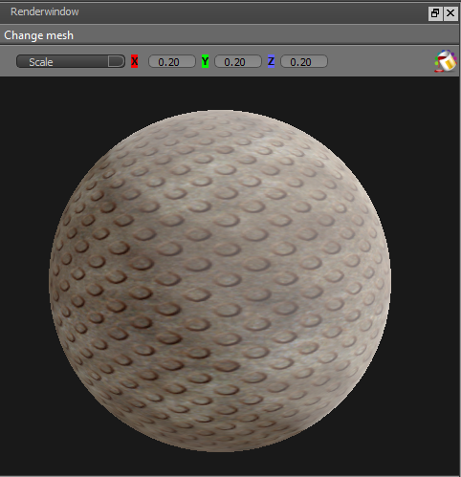

| Action | Command |
| --- | --- |
| Rotate mesh | **Left Mouse Button (LMB)** Drag |
| Move mesh | **Shift +** **LMB** Drag |
| Change mesh | **Change mesh** listbox |
| Change background colour | **Click** on |

Texture window

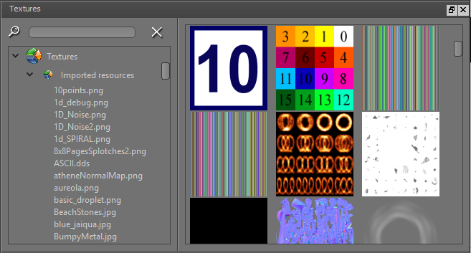

| Action | Command |
| --- | --- |
| Search | Enter search phrase in edit field |
| Reset search | **Click** on |
| Create a subgroup | **Right Mouse Button (RMB) + select** ‘Create a subgroup’ from contextmenu |
| Remove selected subgroup or texture from texture list | **RMB + select** ‘Remove from list’ from contextmenu |
| Collapse / expand | **RMB + select** ‘Collapse / expand’ from contextmenu |
| Import from directory | **RMB + select** ‘Import from directory’ from contextmenu |
| Add texture file(s) | **RMB + select** ‘Add texture file(s)’ from contextmenu |
| Add texture file(s) | **Drag** from file external explorer (eg Windows file explorer) + **drop** on texture window |
| Delete selected texture | **Delete** key |
| New Texture / Samplerblock node  (in Node editor window) | **Drag** from texture listbox + **drop** on node editor window |
| New Texture / Samplerblock node  (in Node editor window) | **Drag** image + **drop** on node editor window |

Properties window

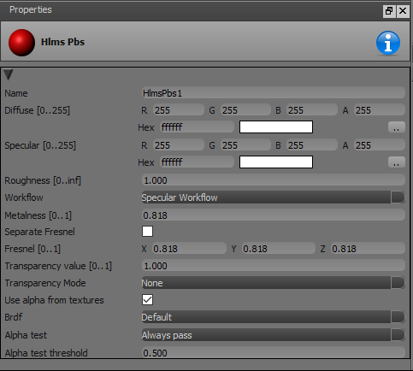

| Action | Command |
| --- | --- |
| Collapse property group | **Click** on |
| Expand property group | **Click** on |

Material browser window

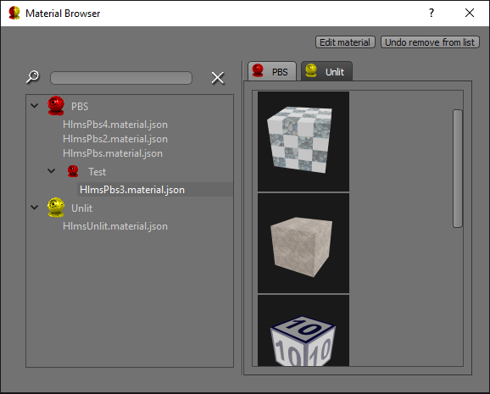

| Action | Command |
| --- | --- |
| Search | Enter search phrase in edit field |
| Reset search | **Click** on |
| Select material for editor | **Doubleclick** on item in listbox |
| Select material for editor | **Click** on item in listbox + button **Edit material** |
| Select material for editor | **Right Mouse Button (RMB) + select** ‘Edit material’ from contextmenu |
| Create a subgroup | **RMB + select** ‘Create a subgroup’ from contextmenu |
| Clone a material | **RMB** + ‘ Clone material‘ from contextmenu |
| Remove selected subgroup or material from material list | **RMB** + ‘Remove from list‘ from contextmenu |
| Collapse / expand | **RMB** + ‘Collapse / expand‘ from contextmenu |
| Undo remove from list | **Click** on item in listbox + button **Undo remove from list** |

Node editor window

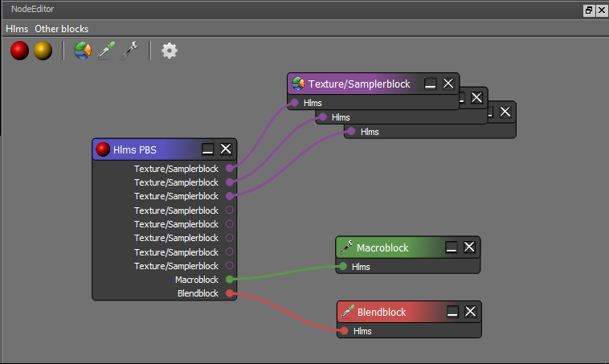

Node editor toolbar and menu

| Action | Command |
| --- | --- |
| New HLMS PBS node | **Click** on  Menu: Hlms 🡪 New Hlms Pbs |
| New HLMS Unlit node | **Click** on  Menu: Hlms 🡪 New Hlms Pbs |
| New Texture / Samplerblock node | **Click** on  Menu: Other blocks 🡪 New Texture/Samplerblock |
| New Blendblock | **Click** on  Menu: Other blocks 🡪 New Blendblock |
| New Macroblock | **Click** on  Menu: Other blocks 🡪 New Macroblock |
| Generate HLMS | **Click** on |

Node editor context menu

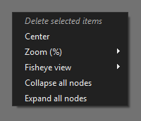

| Action | Command |
| --- | --- |
| Display context menu | **RMB** |
| Center all nodes | Center |
| Zoom in/out (10% - 300%) | Zoom (%) |
| Automatic zoom in/out (based on mouse position) | Fisheye view |
| Collapse all nodes | Collapse all nodes |
| Expand all nodes | Expand all nodes |

Node editor actions

| Action | Command |
| --- | --- |
| Select node | **Click** on header of a node |
| Add to selection | **Ctrl + Click** on header of a node |
| Rubberband selection | **LMB** Drag |
| Delete selected node(s) | **Delete** key |
| Move selected node(s) | **Ctrl +** **LMB** Drag |
| Pan the graph | **Shift +** **LMB** Drag |
| Zoom in/out | **Mouse Wheel Up/Down** |
| Display properties in properties window | **Click** on header of a node |

Workflows

